ASR 6128

Description:

After do shipped wave, we need to indicate the remarks at remark column. Current WMS remark column we not able to indicate the remarks after we have done the ship wave.

Changes:

New function:

## [0.Admin] -> 03. Outbound Exception Amend

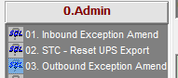

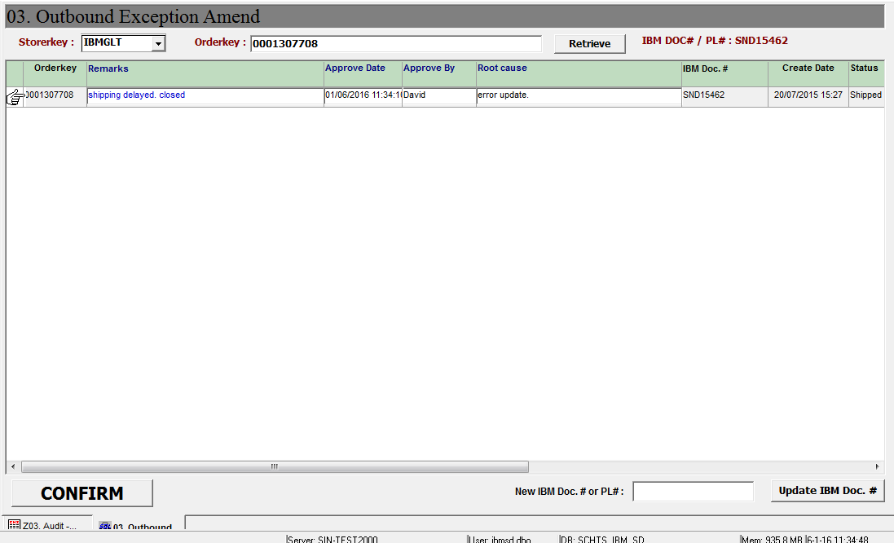

Steps:

1. Select Storerkey
2. Enter Orderkey
3. Click retrieve
4. Enter updated remarks.
5. Approved by and root cause (Optional)
6. Click [Confirm] button, system will prompt confirmation for update, as below screen shot. Click [Yes] to proceed.

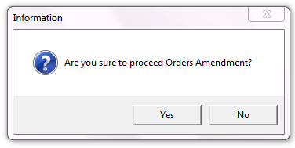

1. Upon success updated, system will prompt success message.

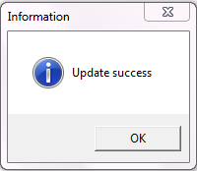

## Report:

**[0.Admin] -> Z03. Audit – Amended Orders**

